Ling D. Tan & Associates, LLC Present

15.3883 Acres of Lands for Sales
on Old Richmond Rd. & Hwy 6 South, Sugar Land, Texas
Exclusive Listing
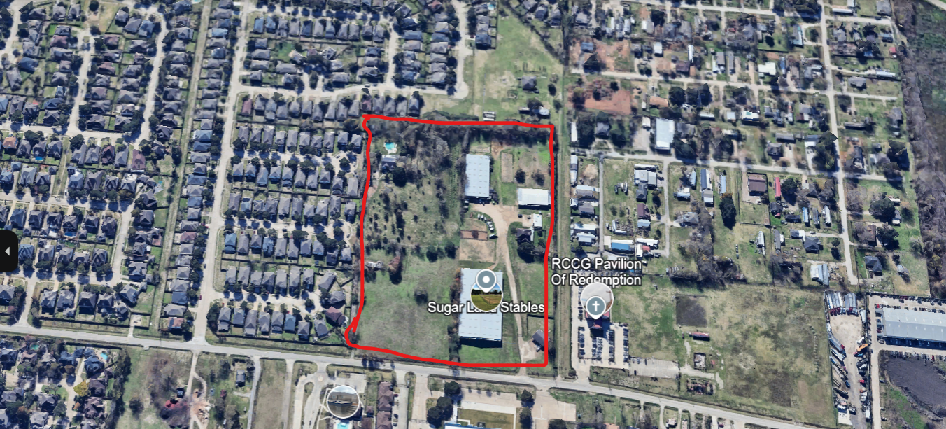
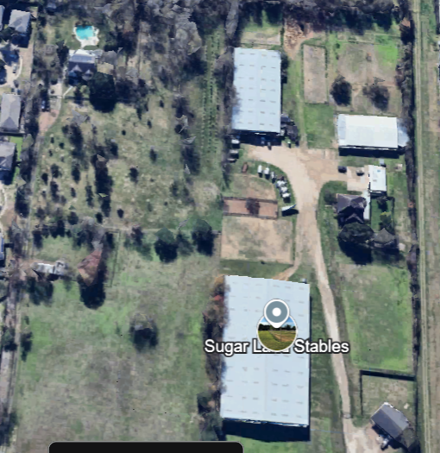
Executive Summary
- Development Tracts
- Total three tracts; 15.3883 AC.
- Tract (1) 15131 Old Richmond Rd – Lot size: 1.8063 acres (Part of a 7.37 acres tract), 0193 JAS HODGE.
- Tract (2) 15133 Old Richmond Rd – Lot size: 3.0948 acres (tract 1 to 3 (PT), (Part of a 7.37 acres tract) 0402 JNO LEVERTON / and Lot size: 0.3009 acres (Part of a 7.37 acres tract) 0402 JNO LEVERTON /
- and Lot size: 2.168 acres (Part of a 7.37 acres tract, tract 3 (PT) \, 0193 JAS HODGE
- Tract (3) 15137 Old Richmond Rd, Sugar Land, TX 77498 – Lot size: 8.0183 acres with a house and barn (tract A&B, 3.292 AC in Abstract 402) 0193 JAS HODGE
*** Ideal of multifamily or residential subdivision development projects ***

Asking price: $7.5 million (negotiable)

Description: Attachment; Survey
Zoning Restrictions: None
Utilities: Sugar Land and MUD.

Highlights
These tracts of lands position in a hottest location in between Sugar Land & Houston’s Old Richmond Road & Hwy 6 area. The properties is surrounding with major commercial retails shops, restaurants, multifamily complexes, public schools, Cullinan Public Recreation Park, the West Oaks & Outlet Mall, Kindred hospital, TIRR Memorial Hermann clinic, the Sugar Land Municipal Airport (or called Global Select at Sugar Land Regional Airport), the Constellation Field Minor League Baseball Park, and many more etc.

A great location for multifamily project and opportunity for residential single family subdivision.

Pitch Desk to Investors

- The neighbor of the City Sugar Land is a Strong Market with high Demand of Housing; especially in the rental multifamily market or single-family residential subdivision which have become affordable but highly desired compare to East or West Coasts.

Sugar Land, Texas is a highly ranked city in the United States. It was ranked one of the best small cities in America by WalletHub, coming in fifth out of over 1,200 cities with populations between 25,000 and 100,000. Sugar Land also ranks in the top 5% of cities in terms of affordability and employment opportunities, and has a low crime rate. According to Livability, it is the fifth best place to live in USA.

- The Hwy 6 and Sugar Land area is flourishing economy and job opportunities market. Sugar Land’s economy flourishes as it embraces a diverse range of light industries, IT, including energy, healthcare, educations, retails, restaurants, and entertainments.

- Family-Friendly Atmosphere. Sugar Land is a family-friendly ambiance, offering top-rated schools in Sugar Land areas, ample recreational activities, and a safe environment.

- Potential for Property Appreciation. As Sugar Land experiences population growth and urban development, the potential for properties appreciation becomes evident. Investing in Sugar Land provides an opportunity for investors to reap substantial returns as property values increase over time.

- Strategic Location. Hwy 6 and Old Richmond Rd. is in the West of Houston area and right at the cross line of Houston to land of the Sugar Land city, it is a prime destination for people and businesses with close by the energy corridor of I-10 area. The City of Sugar Land and City of Houston, as well as the State of Texas are the economic engine of the nation.

- Developing Infrastructure. City of Sugar Land continues to invest in its infrastructure and community amenities, ensuring the city remains attractive to both current and future residents.

- Active Community Engagement. Sugar Land City foster a strong sense of community through various community centers with public library, soccer, basketball, and volleyballs fields, community swimming pools, community events & festivals, and social gatherings that bring residents together. These vibrant communities spirit enhances the overall living experience and contributes to tenant retention for real estate investors.

- Diversification of Investment Portfolio; investing in Sugar Land area allows real estate enthusiasts to diversify their investment portfolios. Real estate assets offer tangible and stable investments that can serve as a hedge against market volatility, complementing traditional investment vehicles.

- Resilience and Stability. Sugar Land’s real estate market has demonstrated resilience and stability over the years. Even during times of economic fluctuations, the city’s strong economic foundation has supported the housing market, providing a secure investment environment for potential buyers.

- Long-Term Wealth Building. In the Long Star State, Sugar Land, Texas stands tall as a beacon of real estate investment potential Boasting a rich history, thriving economy, and a strong sense of community, Sugar Land has emerged as a hotbed for real estate enthusiasts seeking lucrative opportunities.

Listing brokers contact:

Ling D. Tan & Associates, LLC
Sandy Phan-Gillis, associates
Cell/WhatsApp: 832-709-5057.
Email: Houstonteam1sandy@gmail.com

(Survey on page 4)

DISCLAIMER

03/21/2025

The information provided by Ling D. Tan & Associates, LLC is for general informational purposes only. All information on the presentation, and flyer is provided in good faith, however we make no representation or warranty of any kind, express or implied, regarding the accuracy, adequacy, validity, reliability or completeness of any information on the presentation and flyer.

Under no circumstance shall we have any liability to you for any loss or damage of any kind incurred as a result of the use of the presentation or flyer or reliance on any information provided on these documents. Our use of the information and your reliance on any information on the presentation or flyer is solely at your own risk.

The presentation or flyer cannot and does not contain legal advice. The legal information is provided for general information purposes only, and is not a substitute for legal advice.
Accordingly, before taking any actions based upon such information, we encourage you to consult with your attorney and legal professionals or licensed CPA. We do not provide any kind of legal advice. The use or reliance of any information contained on this presentation or flyer is solely at your own risk.

11-2-2015
Information About Brokerage Services
Texas law requires all real estate license holders to give the following information about
brokerage services to prospective buyers, tenants, sellers and landlords.


TYPES OF REAL ESTATE LICENSE HOLDERS: .
- A BROKER is responsible for all brokerage activities, including acts performed by sales agents sponsored by the broker.
- A SALES AGENT must be sponsored by a broker and works with clients on behalf of the broker.
A BROKER’S MINIMUM DUTIES REQUIRED BY LAW (A client is the person or party that the broker represents):
- Put the interests of the client above all others, including the broker’s own interests;
- Inform the client of any material information about the property or transaction received by the broker;
- Answer the client’s questions and present any offer to or counter-offer from the client; and
- Treat all parties to a real estate transaction honestly and fairly.
A LICENSE HOLDER CAN REPRESENT A PARTY IN A REAL ESTATE TRANSACTION:

AS AGENT FOR OWNER (SELLER/LANDLORD): The broker becomes the property owner's agent through an agreement with the owner, usually in a written listing to sell or property management agreement. An owner's agent must perform the broker’s minimum duties above and must inform the owner of any material information about the property or transaction known by the agent, including information disclosed to the agent or subagent by the buyer or buyer’s agent.

AS AGENT FOR BUYER/TENANT: The broker becomes the buyer/tenant's agent by agreeing to represent the buyer, usually through a written representation agreement. A buyer's agent must perform the broker’s minimum duties above and must inform the buyer of any material information about the property or transaction known by the agent, including information disclosed to the agent by the seller or seller’s agent.

AS AGENT FOR BOTH - INTERMEDIARY: To act as an intermediary between the parties the broker must first obtain the written agreement of each party to the transaction. The written agreement must state who will pay the broker and, in conspicuous bold or underlined print, set forth the broker's obligations as an intermediary. A broker who acts as an intermediary:
- Must treat all parties to the transaction impartially and fairly;
- May, with the parties' written consent, appoint a different license holder associated with the broker to each party (owner and buyer) to communicate with, provide opinions and advice to, and carry out the instructions of each party to the transaction.
- Must not, unless specifically authorized in writing to do so by the party, disclose:
  - that the owner will accept a price less than the written asking price;
  - that the buyer/tenant will pay a price greater than the price submitted in a written offer; and
  - any confidential information or any other information that a party specifically instructs the broker in writing not to disclose, unless required to do so by law.

AS SUBAGENT: A license holder acts as a subagent when aiding a buyer in a transaction without an agreement to represent the buyer. A subagent can assist the buyer but does not represent the buyer and must place the interests of the owner first.
TO AVOID DISPUTES, ALL AGREEMENTS BETWEEN YOU AND A BROKER SHOULD BE IN WRITING AND CLEARLY ESTABLISH:
- The broker’s duties and responsibilities to you, and your obligations under the representation agreement.
- Who will pay the broker for services provided to you, when payment will be made and how the payment will be calculated.
LICENSE HOLDER CONTACT INFORMATION: This notice is being provided for information purposes. It does not create an obligation for you to use the broker’s services. Please acknowledge receipt of this notice below and retain a copy for your records.

Ling D. Tan & Associates, LLC
Licensed Broker /Broker Firm Name or Primary Assumed Business Name
License No./Email/Phone: 9015063 / Lingtan1668@gmail.com / 281-300-0392

Ling D. Tan
___________________________
Ling D. Tan & Associates, LLC 430712 Lingtan1668@gmail.com
Designated Broker of Firm / License No. / Email / Phone

Phan, Phan-Gillis
Phan, Phan-Gillis, Associate
Licensed Supervisor of Sales Agent/ Associate
License No. /Email /Phone: 405636 / Houstonteam1sandy@gmail.com / 832-709-5057
Sales Agent/Associate’s Name / License No. / Email / Phone

Initials by: Buyer/or Tenant Seller/or Landlord Date

Regulated by the Texas Real Estate Commission Information available at www.trec.texas.gov
IABS 1-0

