LINK TO ONLINE PROPERTY WEBPAGE: https://www.sellpoint.com/propertyDetails.aspx?caseId=56918572

RecoveRE Holdings, LLC
207 N Calvert Ave
Sutton, NE 68979 $249,999
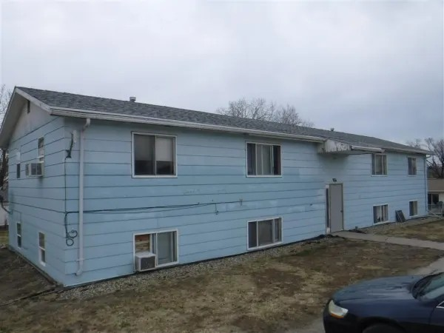
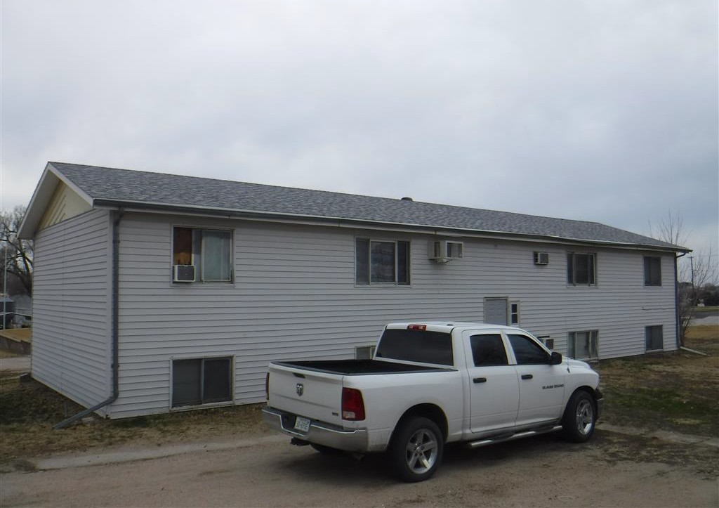

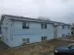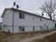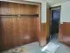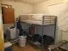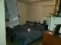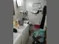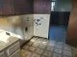
PROPERTY DETAILS

Price: $249,999
Bedrooms: 16
- Bathrooms: 8
- Square Footage: 6,912
- Lot Size: 0.80 acres
- Year Built: 1992
- Basement: Finished Basement
- Heating: Forced Hot Air
- Cooling: Window Unit A/C
- Water: City
- Septic/Sewer: City

- Type: Commercial (General) Two 4 Unit Multi-family Bldgs, one is on Lot 7 & one is on Lot 8
PROPERTY DESCRIPTION
VALUE ADD MULTI-FAMILY with 8 Units in the heart of Sutton, NE and about an hour away from Lincoln, NE Get 2 parcels for the price of less than one, 4 Units on Lot 7 & 4 Units on Lot 8.
ARV: $552,000.00 Rehab: $138,000.00
Cap Rate: 26.89% Layout: 16BD | 8 Bths

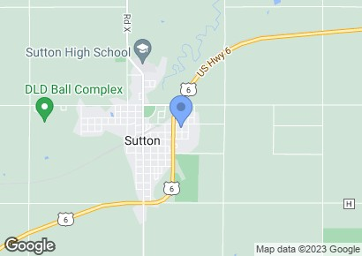
The property offers the opportunity to increase the NOI by 20% once cosmetic changes have been made. Don't miss this opportunity to own this cash cow property. This property consists of 2 lots (Lot 7 & Lot 8) totaling 8/10 of an acre or 34,000 + sqft, giving excess land to add storage units or additional parking that can be rented to residents or to the public for a substantial amount of additional revenue each month. We did this with a property in Cleveland, OH and its been cash cow ever since, the same can be done here.

CONTACT DETAILS
Point of Contact: Glenn M
Phone: 973-202-2563
Email: Glenn@RecoveREHoldings.com
Website: http://www.RecoveREHoldings.com

