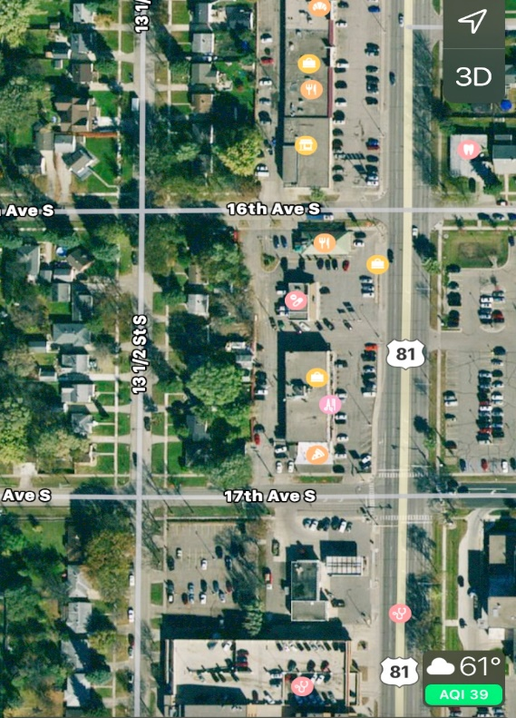
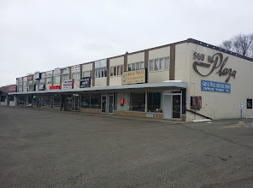
South Plaza Properties
______
Mark Lane
______
1621 University Drive
______
(701) 781-4585
South Plaza
Commercial
Block

Rare opportunity to develop a large site on a prime commercial block in the heart of thriving Fargo, ND |  |  |  | Prime Commercial  3 acres on a prime commercial street with high traffic and visibility near a major interstate intersection.  26,000 cars per day!  Incredible development potential!
 | Location  3 acre property near a major interstate intersection. 11 commercial and residential buildings.  - High traffic and visibility  - Adjacent to 2 major medical centers.  - Vibrant commercial zone with retail, groceries, restaurants, Starbucks |  | Site Features  Main building is called “South Plaza” and is a large combination strip mall and office building.  2 additional commercial buildings are a free-standing pharmacy and a restaurant with separate parking.  Entire block of 8 residential houses adjacent to the commercial properties complete the block.  Shopping center is approx 10,000 sqft of store front commercial space with approx 10,000 sqft of office space on the second floor.  Commercial buildings are approx 1500 sqft each.  The 8 houses are all 2-3 bedrooms, 1-2 baths with garages, and each approx 1000 sqft on main floor. Most have finished basements for additional sqft. |  |  |  | Outstanding Access  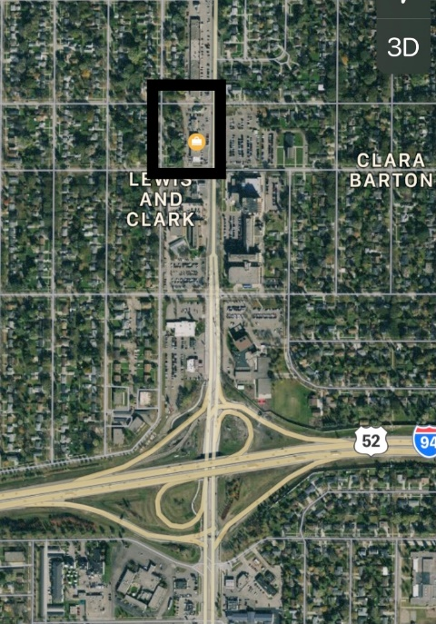  Financials  Buildings assessed separate value in 2020 was $2,750,000. Asking $3,900,000 for properties combined together for re-development.
 |  |  | Outstanding opportunity for the right investor

