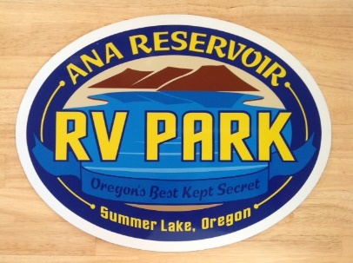
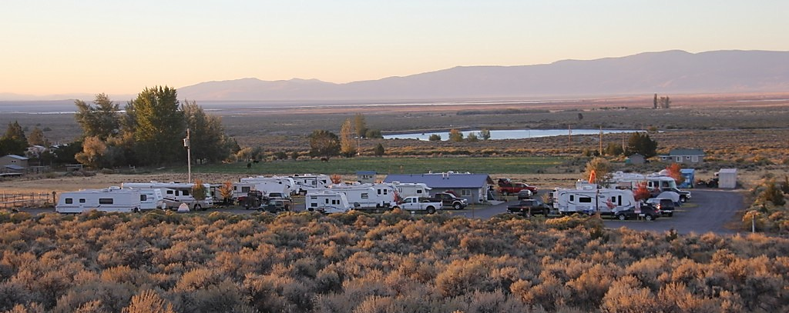
84594 Carton Lane, Summer Lake, Oregon
4.47 Acres
24 R.V. Spaces
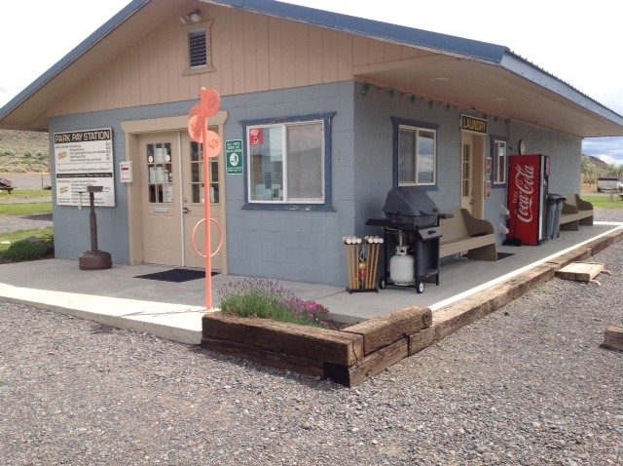
Bathroom, Shower & Laundry
Duck & Fish Cleaning Building
Storage Area
Children's Playground Area
R.V. Dump Station
“Cleanest Air, Quietest Nights in Oregon”

Price: $425,000
Cap Rate: 6.6 %
2018 Taxes $1,950

Important to know:
Possible owner financing available
First right of refusal on beautiful home next to the R.V. park
Price includes approx. $18,000 personal property
Inventory upon request

(additional views at: www.anareservoirvpark.com)
