Capture a Premiere Concord Pike Location!!!
1707 Concord Pike
MLS# 7113831 CIMLS.com# 972527 Loopnet ID# 3802494
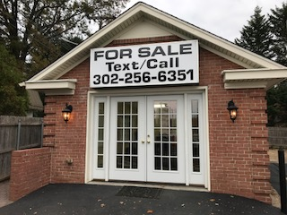
A Fabulous Entrepreneurial Opportunity!!!
Offered at $259,000, or $2500.00 per Month to Lease
Great opportunity to lease or own a free standing commercial building with a high profile Concord Pike location!!! A complete interior and exterior renovation has just been completed. This property is turn key for the next small business owner or investor. Beautifully maintained for the past 17 years by the current owners, this property offers tremendous road exposure. Approximately 50,000 cars pass by this Concord Pike location daily!!! Capitalize on cars sitting at the red light right in front of your business location!!! For the investor, this property also has a ten year triple net rental history. Parking in front of building is for the exclusive use of business owners and their business invitees. Additional parking available in business complex offering a total of 15 parking spaces, including five spaces in the rear parking area. Surrounded by numerous established business, retail, restaurant and healthcare facilities, as well as established and newer residential communities, including Fairfax Shopping Center, Astra Zeneca, DuPont Country Club, Nemours DuPont Hospital, & Independence Mall.
Impeccably Renovated Throughout…

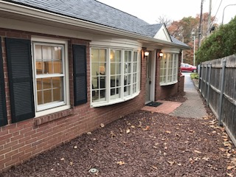

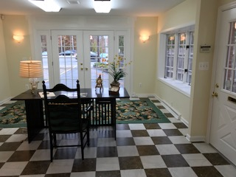

New Installation of Double French Doors Enhances Concord Pike Curb Appeal…Advertise your business as cars sit at the red light right in front of this beautiful building!!!
Beautiful Ceramic Tile Floor…

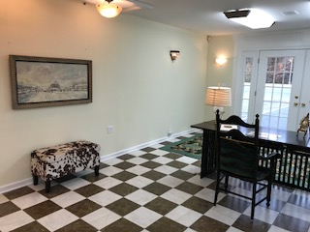

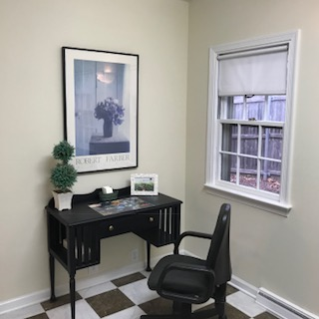
Private Rear Office Space…
Freshly Painted Throughout…

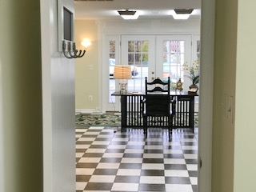

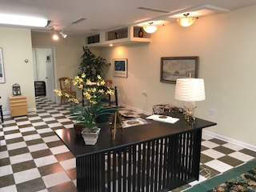
Perfect for a small office, retail, service business, etc…

Most Recent Interior & Exterior Renovations…
- Newer exterior siding and gutters, including capping of windows and doors
- Updating of all interior and exterior electrical, including all new interior and exterior lighting fixtures, installation of additional interior and exterior outlets, & illumination of exterior signage, including a lighting sensor for exterior signage attached to front of building
- Installation of new shutters
- Installation of new ceramic tile floor
- Interior walls, trim, bow window muttons & new Double French Doors just freshly painted (Double French Doors were primed upon recent installation)
- Entire exterior of building just power washed
- Repaving of front parking area & common driveway; originally required removal of front bed, soil and shrubbery
- Removal of interior vestibule area and two interior closets to open up front room, establishing an improved commercial space flow and floor plan, along with opening up more available usable square footage
- Removal of front brick wall and window to install Double French Doors – significant improvement of curb appeal from Concord Pike vantage point
- Custom Millwork surrounding Double French Doors
- Updated restroom including installation of new toilet, vanity, plumbing fixtures, door, custom wall tissue cabinet & mirrored wall cabinet
- Exterior and interior refurbishing of original Anderson bow windows
- Exterior and interior refurbishing of original side entrance door and back entrance door and back entrance screen door
- Newer installation of exterior stone resurfacing
- Improved Easement Rights through New Castle County Department of Land Use. Parking in front of 1707 Concord Pike is for exclusive use of owners of 1707 Concord Pike (Two parking spaces available), additional shared parking available to owners of 1707 Concord Pike including 8 parking spaces in front of Triplex Building, and five parking spaces behind Triplex Building, comprising a total of 15 parking spaces
- Newport Style white vinyl fence to be installed on left side of property line facing property from Concord Pike vantage point

Zoned for 18 foot free standing illuminated sign, in addition to already permitted and installed illuminated signage attached to front of building
For More Information Contact:
Adria Charles & Gary Staffieri
610-883-3288 (cellular) – Adria
302-256-6351 (cellular) - Gary
adriaacharles@gmail.com

