FLOOR PLAN LEGEND
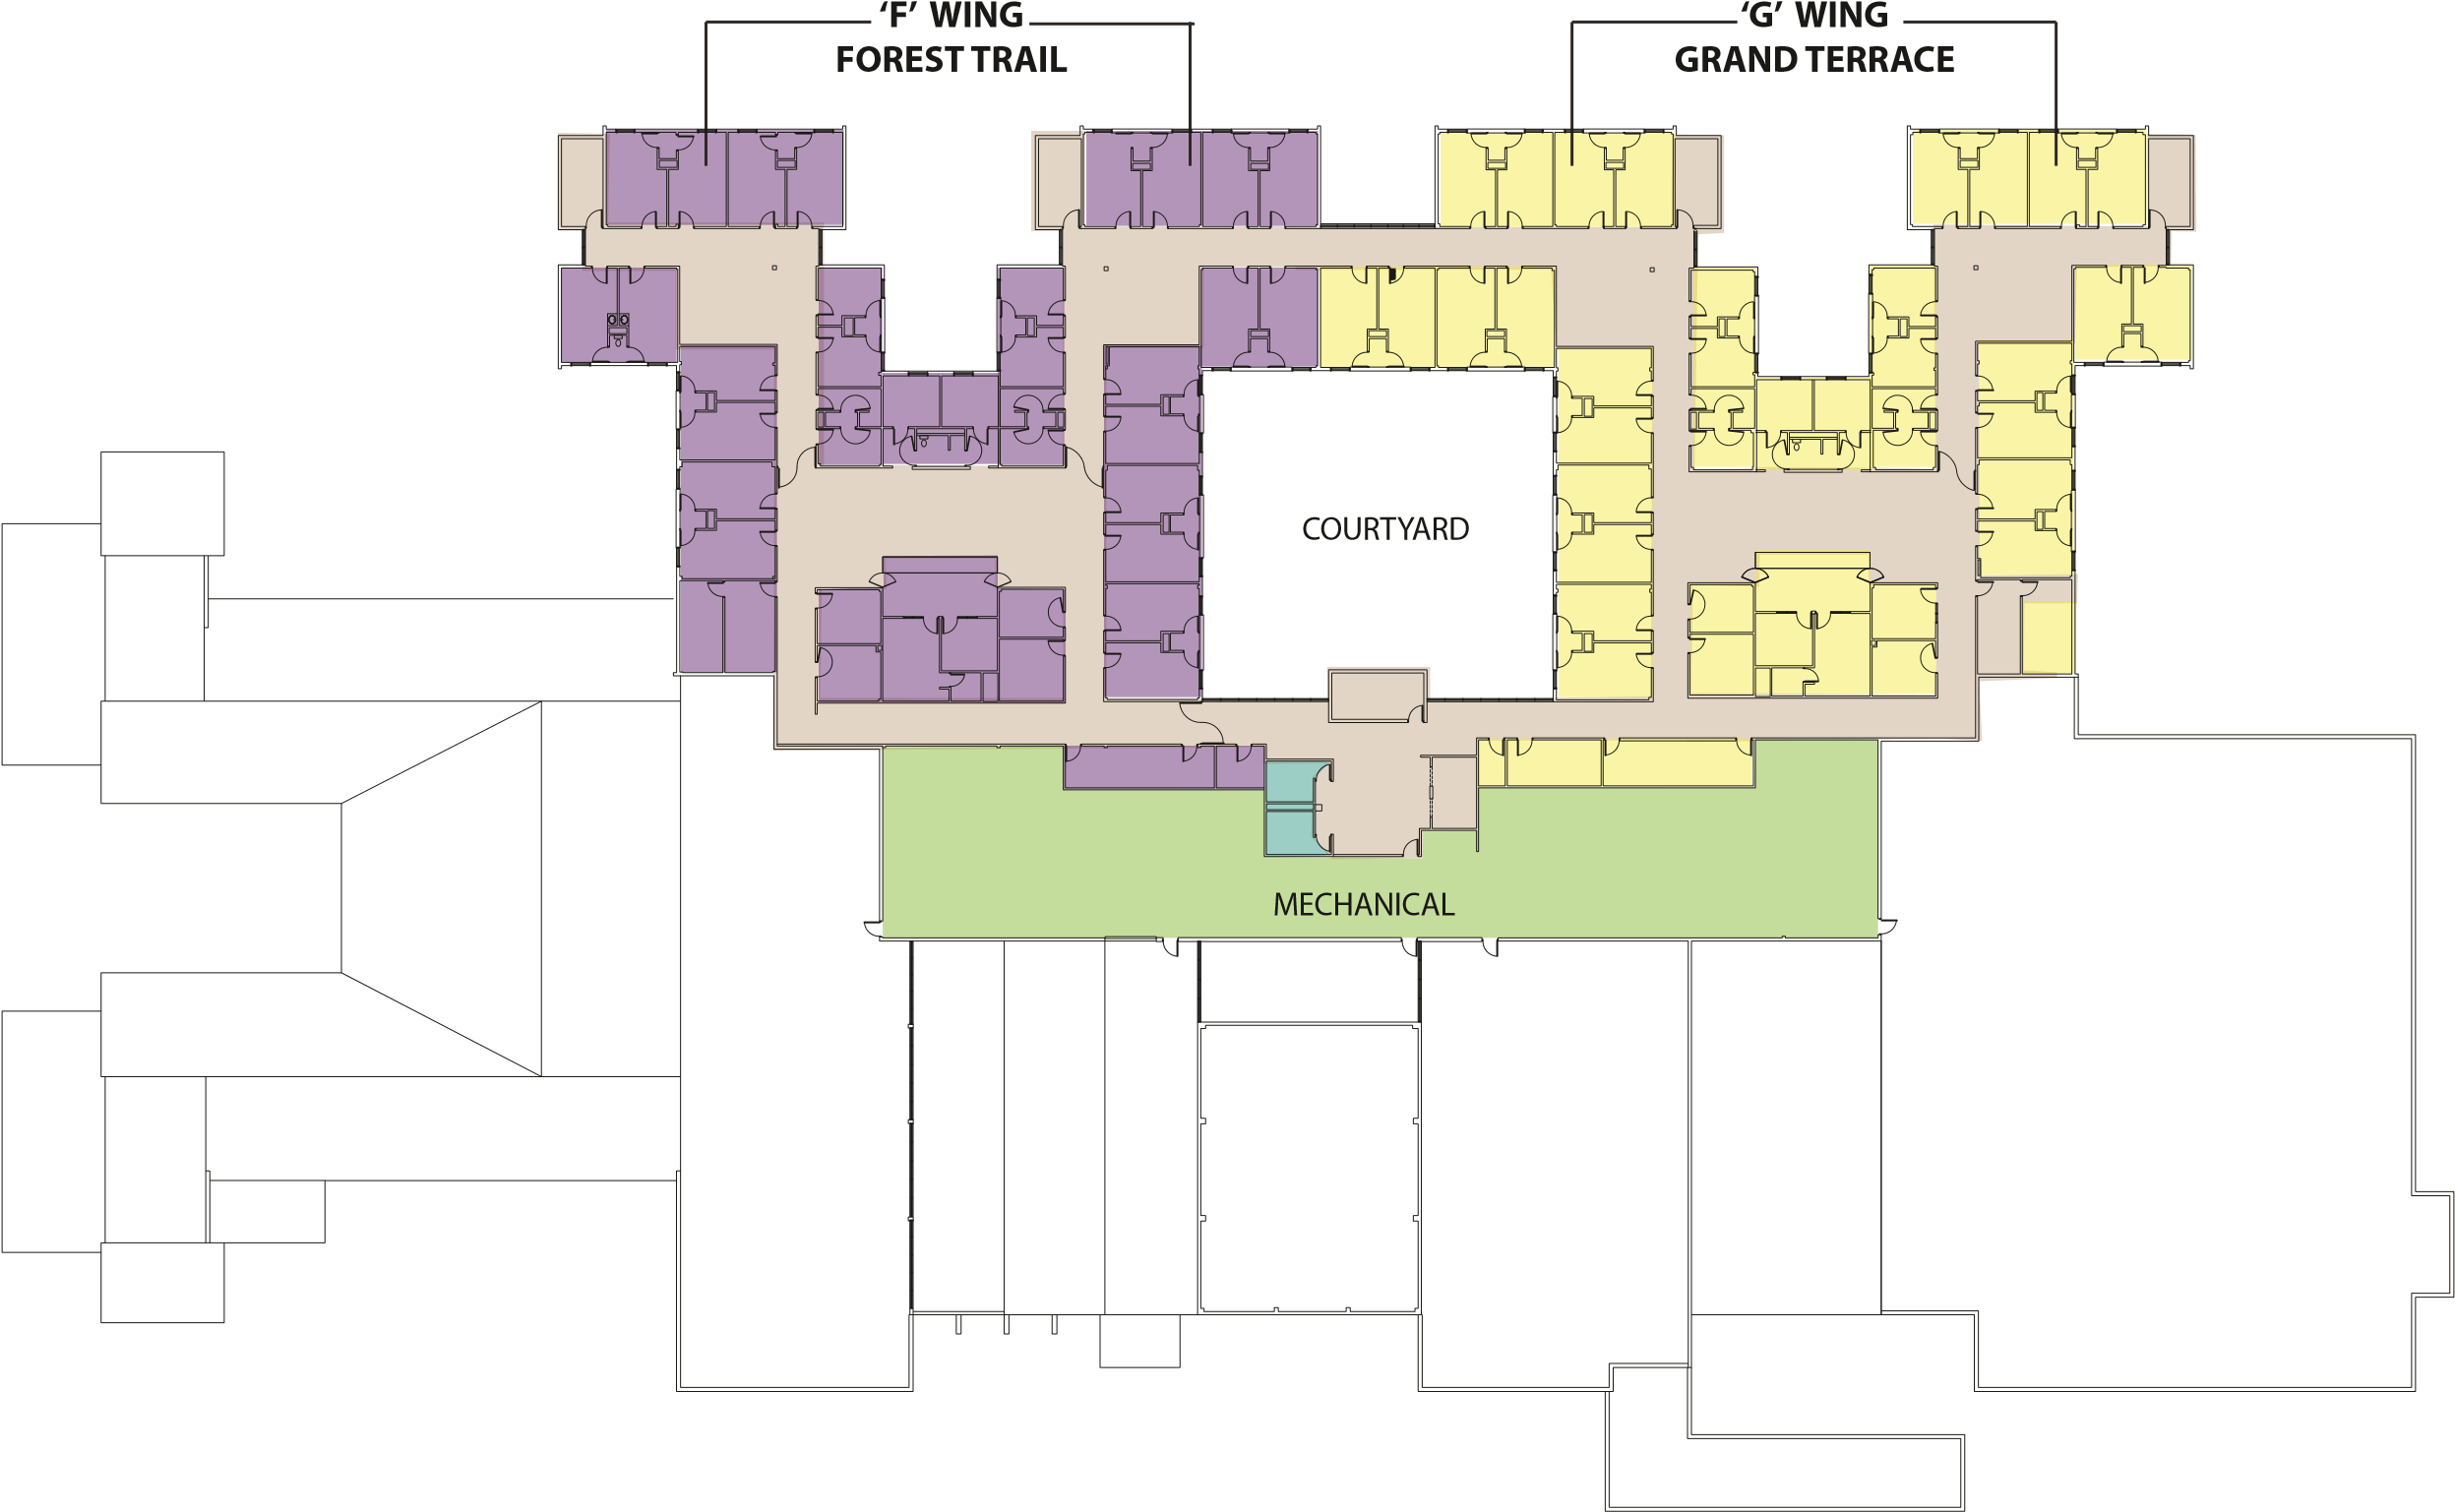
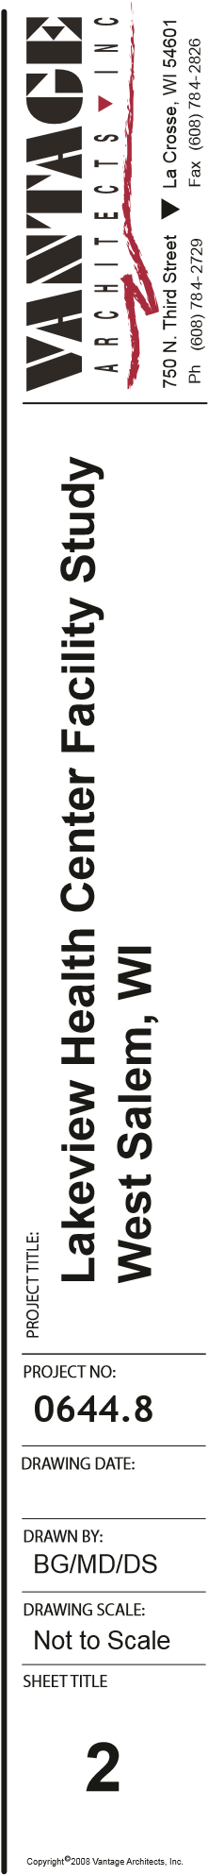
‘F’ WING MECHANICAL
‘G’ WING SUPPORT AREA

UPPER LEVEL FLOOR PLANNOT TO SCALE North

