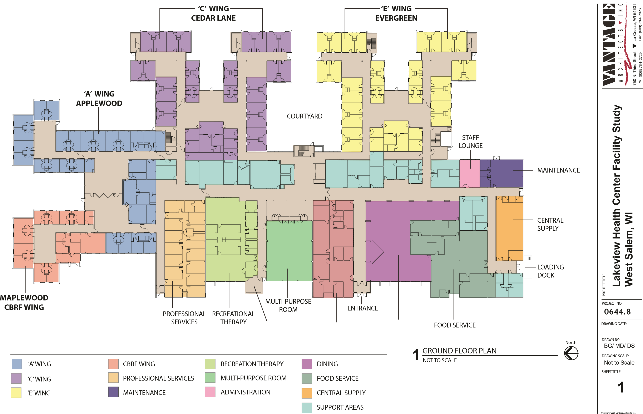
GREENHOUSE ADMINISTRATION DINING
FLOOR PLAN LEGEND

